Restoration of Chromium Contaminated Soil-Groundwater Systems at COPR Site in Rania and Khan Chandpur Villages, India

Objectives
- To assess the soil and groundwater quality and conduct questionnaire-based surveys to evaluate Cr contamination issues and community awareness in Rania and Khan Chandpur villages.
- To investigate the fate, transport, and remediation potential of Cr in soil-groundwater systems through batch and column experiments.
- To study the fate and transport of Cr at a field scale using 3D tank-based experimental setups in and around the Rania-Khan Chandpur villages.
- To implement capacity-building programs and village-level interventions to enhance community participation in sustainable soil and groundwater management in the study area.
- Groundwater sampling and analysis were conducted in July 2024 to assess Chromium levels after COPR removal from the Rania–Khan Chandpur site.
- A village-level survey was carried out in Khan Chandpur to gather community insights on groundwater quality, impact and awareness of contamination.
- A 3D laboratory tank experiment was performed to simulate and visualize the dispersion behaviour of Chromium in soil-groundwater system.
- A capacity building program was organized to educate villagers about Chromium contamination, its health impacts, and safe water practices.
- Batch adsorption experiments were conducted to study the retention of Chromium in sandy and Rania soils under varying pH, temperature, and moisture conditions.

Leaching of Chromium: 1 D column experiment

Objective: To study the release and transport of chromium from Rania-Khan Chandpur COPR site using 1-D column experiment.
Samples and Characteristics of samples: The COPR samples collected from the Rania-Khan Chandpur COPR site. Experimental parameters like length of the column, cross sectional area of the column, pH, bulk density, volumetric water content, pore volume, porosity, organic matter content and flow rate will be determined.
- Bulk density will be calculated as the dry weight of the packed material divided by the volume occupied by the material.
- Pore volume will be calculated by the dry weight of the packed material divided by the saturated weight of the material.
- Porosity will be calculated as (1 - (Bulk Density ÷ Particle Density)) x 100.
- Organic matter content will be calculated as Organic matter (%) = Total organic carbon (%) x 1.72.
Column Experiment:
A column experiment will be performed with the COPR soil collected from the Rania-Khan Chandpur site. The COPR will be packed into the columns of length 35 cm and internal diameter 8 cm. The columns will be saturated from up to bottom. A peristaltic pump will be used to maintain the flow rate.
For monitoring the Cr flow, a total of 4 ports, 7 cm apart each will be made on the column. The samples will be collected every 12 hours with the help of 10 ml syringe. The collected water samples will be tested in the MP-AES for Chromium and other co-pollutants.

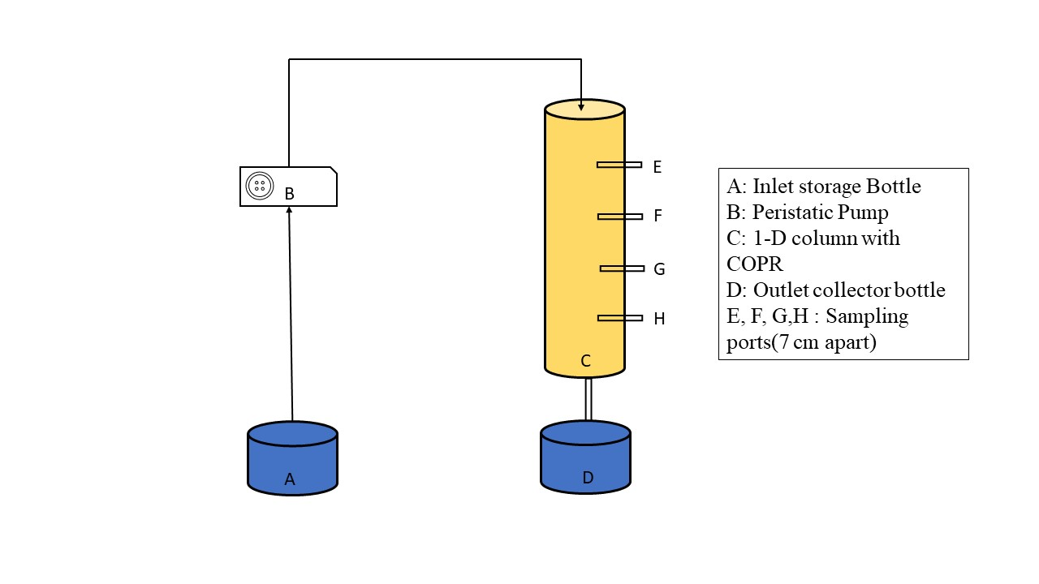
Fig. 1: Scheme of the experimental setup

3-D Tank Experiment
- First, the soil core will be isolated manually and by mechanical means from the field.
- A steel panels structure mounted around the samples and a basal cutting plate was used to separate the core from the surface.
- The basal cutting plate was removed in the laboratory, and the core will be placed in the glass tank in laboratory which will be free from any kind of water as well as material leakage.
- The tank was connected to a water flux. A constant water flow (left to right) will be allowed to flow first to maintain a base groundwater flow velocity in the horizontal direction.
- A piezometric controlling device will be connected to the soil core.
- COPR will be added at the left side of tank which will be allowed to flow in water flow direction.
- Samples will be collected regularly at fixed duration and will be analyzed for chromium content.
- When the COPR concentration is obtained on the right side, the flow path will be determined.
- Now for the remediation of the COPR, the fungi will be used in the path of COPR flow in the setup tank.
- The samples will be collected again for chromium content.
- After comparing the chromium content before and after the adding of fungi, the efficiency of fungi-based remediation will be determined.

